Contents
Support for Non-Marker Interfaces and Class operations: 2
Support for 3rd party JARs 13
Testing 13
Support Bi-Directional Self Associations 15
Testing 16
Automated JUnit Test Case Generation 17
Testing 18
Not-null attributes in generated Hibernate mapping files 18
Parameterized Constructors 19
Testing 19
Custom getter methods 20
Testing 20
Support for Comparable Interface 21
Testing 21

Support for Non-Marker Interfaces and Class operations:

GForge Trackers:
[#30524] SDK Code Generation - Parameterized Constructors – catissue
[#30511] SDK Code Generation - Custom Getter Methods – catissue
[#30510] SDK Code Generation - Provide Support for Non-marker Interfaces within the Logical Model – catissue
[#30508] SDK Code Generation - Support for Implementing Comparable interface – caTissue
[#30749] SDK Code Generation - Support for Third-Party Jars within the Code Generation Process - caTissue

Summary:
SDK code generation uses XMIHandler to read UML Model in Java representation. Operations on Class or Interface elements have not been supported by XMIHandler. To accomplish above mentioned feature requests, XMIHandler is updated to support operations on Class and Interface elements. SDK codegen is updated to use XMIhandler UMLOperation APIs to generate code including operations and corresponding body modeled in a given UML Model.

XMIHandler:
XMIHandler has been in use to read, parse and write EA and ArgoUML models in several projects including SDK. XMIHandler provides way to represent UML model s in Java object representation and provide convenience APIs to access them. XMIHandler do not support operations on Interfaces or Classes.
To support non-marker interfaces, XMIHandler is updated to recognize operations modeled on Interface and Class elements. More generally, method declarations have following components, in order:
- Access Modifiers—such as public, private, protected.
- Modifiers – such as abstract, static, final, native, strictfp, or synchronized
- The return type—the data type of the value returned by the method, or void if the method does not return a value.
- The method name—the rules for field names apply to method names as well, but the convention is a little different.
- The parameter list in parenthesis—a comma-delimited list of input parameters, preceded by their data types, enclosed by parentheses, (). If there are no parameters, you must use empty parentheses.
- An exception list— comma-delimited list of exceptions.
- The method body, enclosed between braces—the method's code, including the declaration of local variables, goes here.
Even though XMI has been a standardized format, different modeling tools represent a UML model differently through XMI extensions. XMIHandler supports reading, writing UML models from EA and ArgoUML.

Following section lists instruction to model operations using EA and ArgoUML to work with XMIHandler.

EA:
To add an operation on an Interface, right click on selected Interface and click on “Operations”.
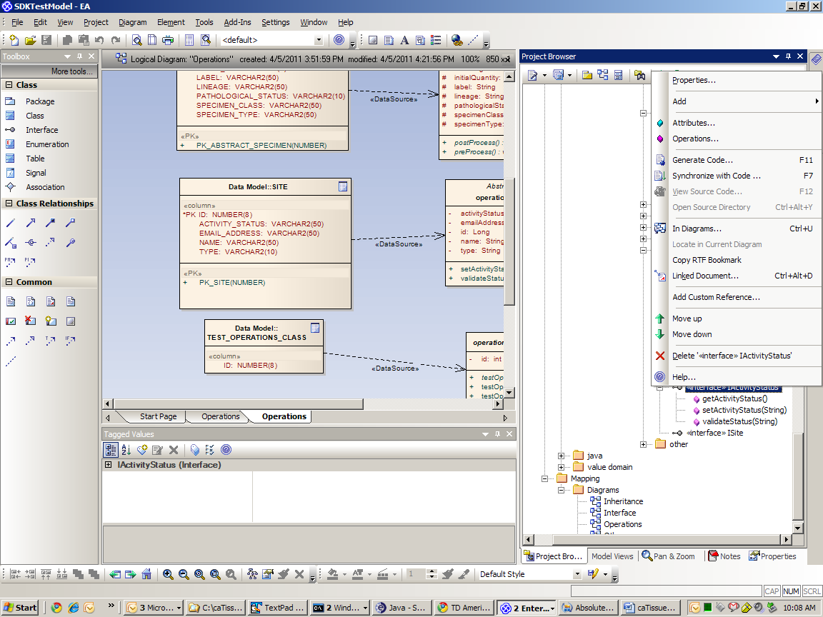

Add required operations including their return type, parameters and modifiers. XMIHandler supports “Abstract”, “Return Array”, “Synchronized”, “Static”, “Const” properties on an operation.

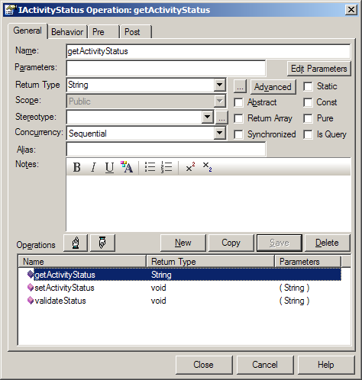

Add “throws” taggedValue name and its value to add any exceptions on an operation.
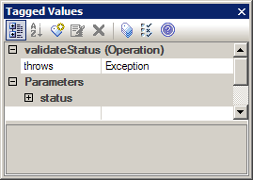

Modeling operations also supports adding behavior of the operation. Following screenshot shows adding behavior for an operation on a Class (not on Interface). If you are referring to any third party APIs in here, make sure you use fully qualified names of those.
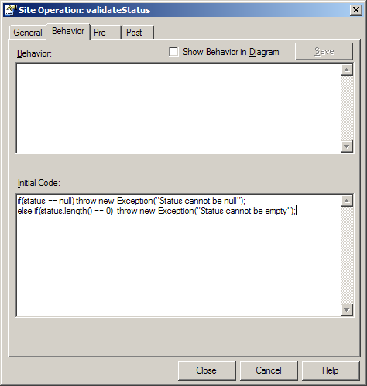

ArgoUML:
After adding an Interface, right click on Interface and click on “Add” and “New operation”.
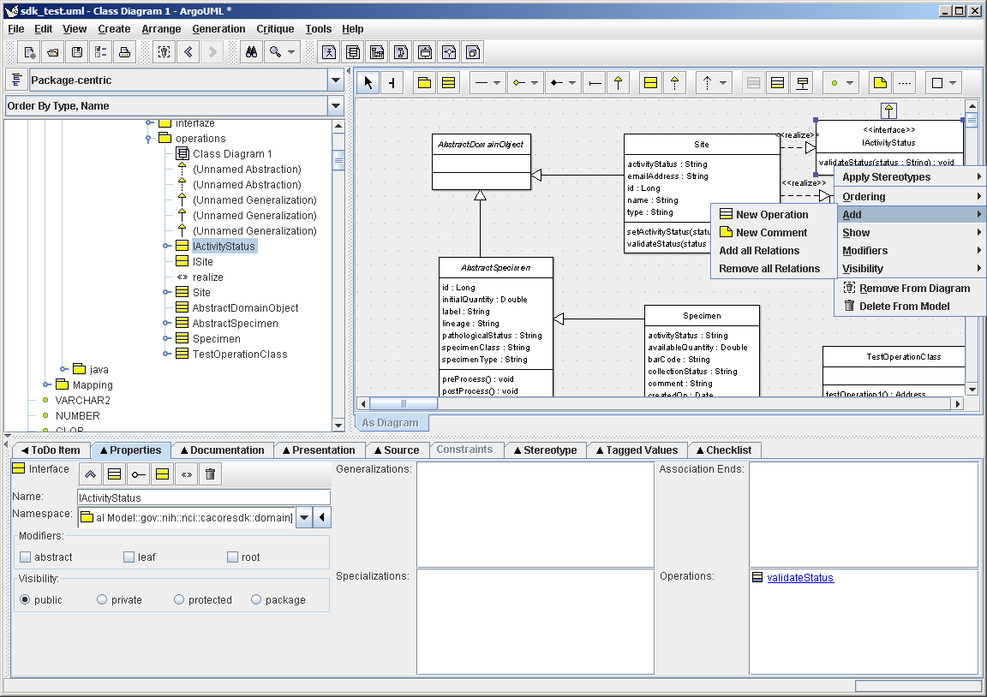

Fill in operation name, modifiers, return type and parameters. XMIHandler supports all Visibility options, Concurrency (guarded, concurrent options), modifiers (abstract, leaf, static) options. Specification field in the bottom right corner is used to add behavior on class operations.
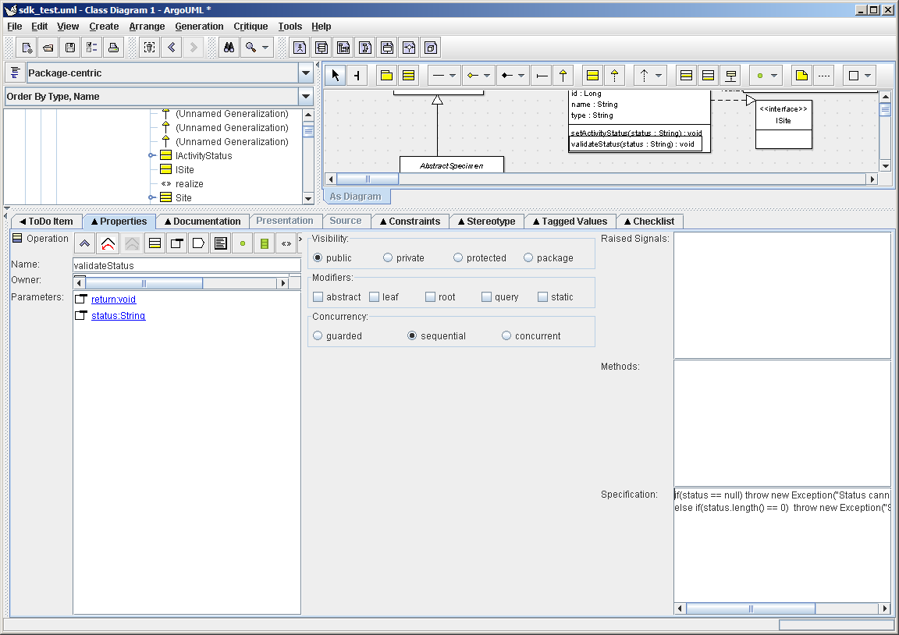
Similar to EA, you can add exceptions on an operation. For multiple exceptions, same tag name should be used with comma-delimited exceptions as tag value.
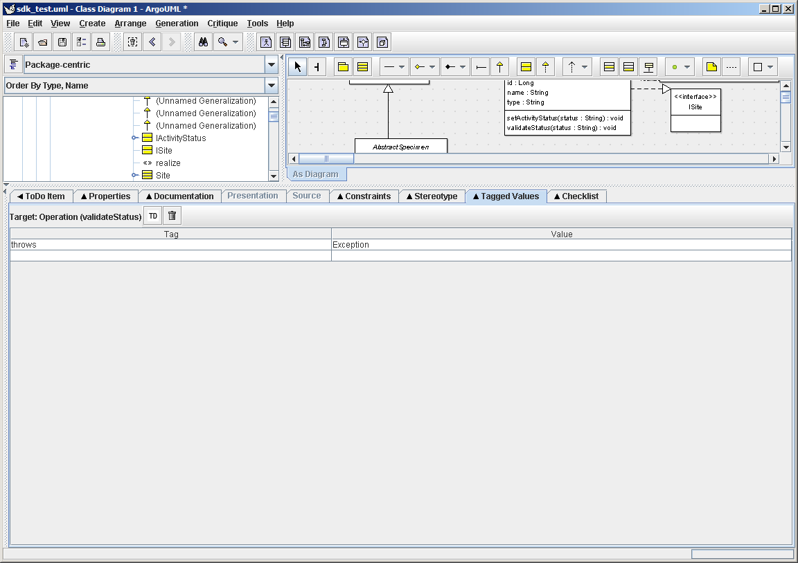

XMIHandler API:
Following UML diagram shows class model to support Operations on Interface and Class elements. Following classes are added to XMIHandler API to support this change:
UMLOperation
UMLOperationParameter
UMLStaticModifier
UMLSynchronizedModifier
UMLFinalModifier

Both UMLClass and UMLInterface are updated to have collection of operations.

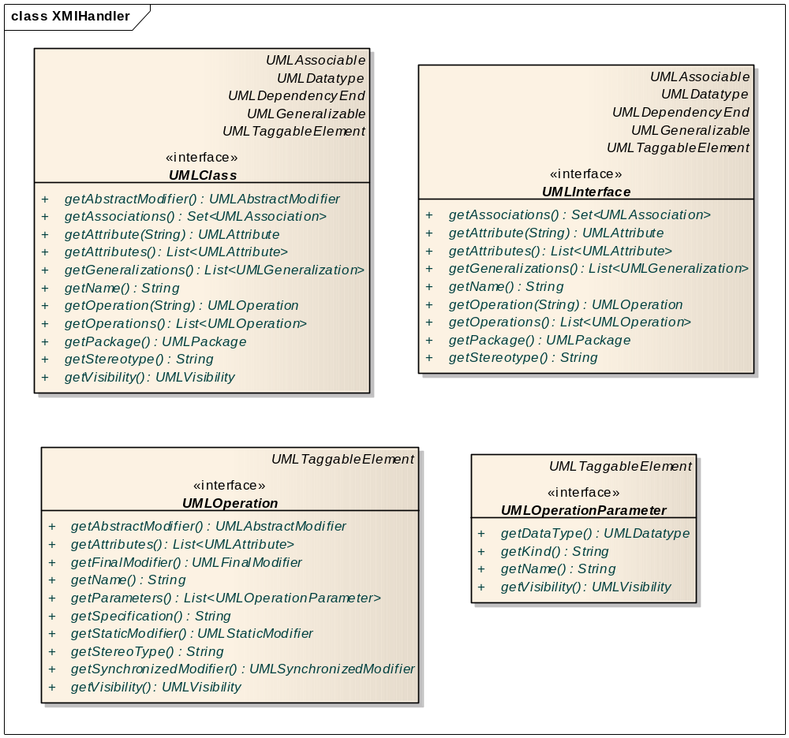

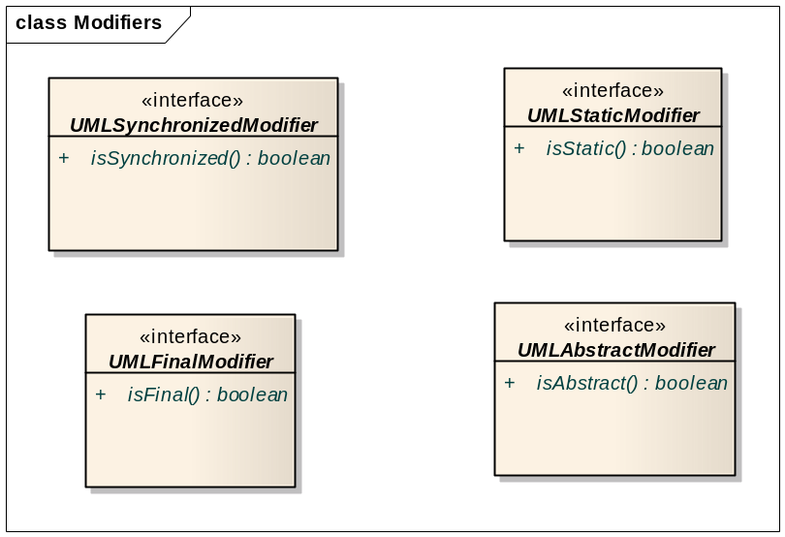

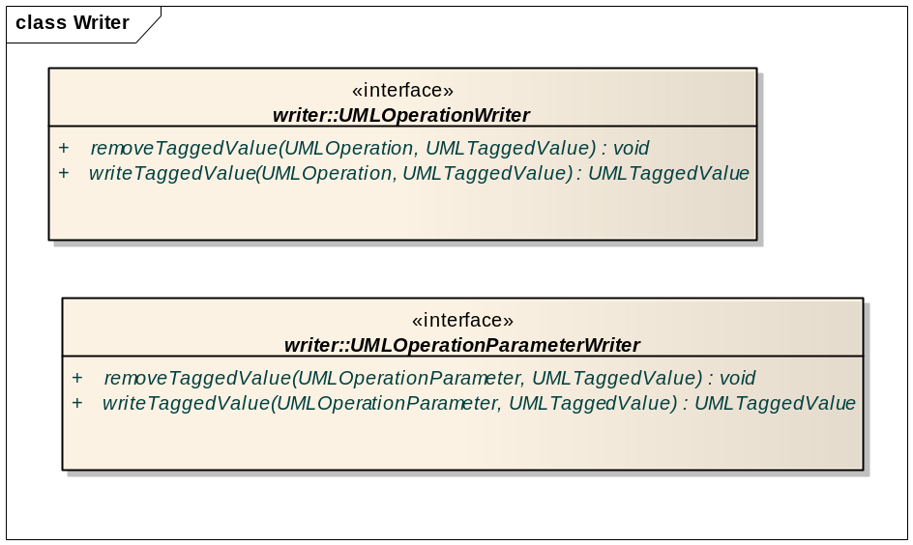

SDK – Code Generation:
SDK is built on Object oriented principles and MDA standards to help its users to lower the entry barrier to generate interoperable applications. From a standardized model, with less or no manually coding, SDK can generate a working system to share data. SDK Code Generation, which accepts a UML model as input and produces java classes and other artifacts such as a standard XML Schema (xsd) that can be used by standard client APIs. The code generator generates the artifacts from a UML model using principles of Model Driven Architecture that are consumed by the runtime system.
Following validation rules are put in place to support operations on Interface or Class UML elements.
- A class that is implementing an Interface with operation(s) must implement the operations in its model.
- A class can overload or replace default getter or setter operations. A getter or setter method is modeled as part of UMLModel would replace method generated using attribute name.
- JavaDoc for operations follows same tags (“documentation” or “description”) as class or attribute
- Operation signatures are validated to make sure if a Class implementing an Interface or extending Abstract class is implementing the operations.
- Validations of operation name, operation overloading rules are not checked during model validation. They are checked during compilation of generated system.
- Operation behavior (code) is checked during compilation of generated system. As it is mentioned in XMIHandler documentation, operation behavior should use full qualified names of any 3rd party objects.
Issue resolution:
[#30524] SDK Code Generation - Parameterized Constructors – catissue
Parameterized constructor can be modeled as an operation on a desired class element.

[#30511] SDK Code Generation - Custom Getter Methods – catissue
Custom getter operation can be modeled with custom code. This custom getter operation would replace default getter operation. Default getter operation follows “get<AttributeName>()” format.

[#30510] SDK Code Generation - Provide Support for Non-marker Interfaces within the Logical Model – catissue
A non-marker interface is an Interface with operations defined. A Class implementing a non-marker interface has to implement operations for successful compilation and execution. This can be achieved by adding operations to Interface and add same operations and their behavior on implementing Class.
Even if a non-marker interface is from an external jar, it has to be modeled in logical model so that any class can model itself to “realize” the interface. Because the interface already exists in an external jar, it should not be generated are part of code generation. Instead, implementing class should be referring to the external jar.
Following property in codegen.properties has to be set to exclude interface from code generation.
Ex:
EXCLUDE_NAME=edu.wustl.common.domain.AbstractDomainObject
Following property in codegen.properties has to be set to include external jars as part of code compilation in code generation process.
Ex:
3RD_PARTY_JARS_DIRECTORY=c:\sdk4.2\external\jars

[#30508] SDK Code Generation - Support for Implementing Comparable interface - caTissue
Custom operation “compareTo(Object obj)” can be modeled with operation behavior necessary to support comparable implementation.

Support for 3rd party JARs
Currently, any third-party jars that the generated classes are dependent upon for compilation and runtime need to be manually placed within the code generation directory: /sdk-toolkit/software/target/modules/lib/runtime. Third-party jars also need to be manually deployed, as the current build process does not include them within the generated and packaged war file.

The goal is to enhance the build process so that users will be able to place all third-party jars within a given directory, and the build process will take care of copying them to the compilation and war staging directories so no manual intervention will be required.

https://gforge.nci.nih.gov/tracker/index.php?func=detail&aid=30749&group_id=148&atid=804
As part of the implementation, the following property has been added to the codegen.properties file:
3RD_PARTY_JARS_DIRECTORY=
The value of this property is the fully qualified path name of the directory containing any 3rd party jars. This location is used during compilation of the SDK generated system and at deployment time as well while staging and packaging the war file for distribution. The build process will pick up any and all files within the specified 3rd party directory containing a *.jar file suffix.
NOTE: Use forward slashes ("/") within the directory path name. Otherwise, if using backward slashes ("\"), be sure to escape them (e.g., \\).

Testing
To test the enhancements made to provide support for 3rd Party jars, follow these steps:

- Download the catissue EA model , xmi, and codegen.properties files attached to GForge tracker [#30749] SDK Code Generation - Support for Third-Party Jars within the Code Generation Process – caTissue. Place the model and xmi file within the <project generation directory>\models directory, and the codegen.properties file within the <project generation directory>\build directory.
Note: the codgen.properties file is excluding and abstract class, AbstractDomainObject, via the EXCLUDE_NAME property:

EXCLUDE_NAME=edu.wustl.common.domain.AbstractDomainObject

This class is found in the EA model, but should not be generated, as the actual implementation is found in a third party jar which will be supplied to the system shortly via a jar file in a subsequent step below.
- Run the code generator as usual using the “dist” or “build:SDK” targets. The build compilation process should fail, reporting errors such as the following, which indicate that the exclude class in question cannot be found:
    - -compile:application-code:
    - [mkdir] Created dir: C:\dan\dev\caCore\CACORESDK_423_JUNIT_GENERATION_02_24_2011\sdk-toolkit\example-project\target\dist\exploded\output\example\codegen\classes
    - [javac] Compiling 225 source files to C:\dan\dev\caCore\CACORESDK_423_JUNIT_GENERATION_02_24_2011\sdk-toolkit\example-project\target\dist\exploded\output\example\codegen\classes
    - [javac] C:\dan\dev\caCore\CACORESDK_423_JUNIT_GENERATION_02_24_2011\sdk-toolkit\example-project\target\dist\exploded\output\example\codegen\src\edu\common\dynamicextensions\domain\integration\AbstractFormContext.java:3: package edu.wustl.common.domain does not exist
    - [javac] import edu.wustl.common.domain.AbstractDomainObject;
- Download the catissueCommon.jar attached to GForge tracker [#30749] SDK Code Generation - Support for Third-Party Jars within the Code Generation Process – caTissue. Place this jar file in a temporary directory of your choosing, such as C:\Temp.
- Modify the codegen.properties 3RD_PARTY_JARS_DIRECTORY property, and add the fully qualified path of the temporary directory selected in the previous step; e.g., C:\\Temp. Note that since backslashes (vs. forward slashes) are being used, each backslash is “escaped” using an additional backslash character (“\”). This is required by the ant scripting system.
- Run the SDK code generator process as usual again using the “dist” or “build:SDK” targets. This time the build compilation process should complete successfully. This indicates that the catissueCommon.jar file, which contains the Abstract test class in question, was found and used during the build compilation process.
- Verify that the install.properties file properties are correctly configured for your environment.
- Run the SDK deployment process as usual, using one of the deploy:local:install:* targets, such as deploy:local:install:no-build. Confirm that the catissueCommon.jar has been copied to the <project-generation directory>\target\dist\exploded\output\catissue\lib\runtime\ directory. Also check that the same jar file is included within the <project-name>.war file, located within the \<project-generation directory>\target\dist\exploded\output\catissue\package\server\tomcat\webapps directory.

This concludes the testing of the enhancements made to provide support for 3rd Party jars.

Support Bi-Directional Self Associations
The SDK code generator does not currently provide support for generating bi-directional self associations. Changes will need to be made to the Domain class generator, Hibernate Mapping file generator, and the newly created automated JUnit Test Generator to provide support for Bi-Directional Self Associations.

See https://gforge.nci.nih.gov/tracker/index.php?func=detail&aid=30748&group_id=148&atid=804.
The following diagrams illustrate the new SDK Test model scenarios that have been added to test the bi-directional self-association changes:
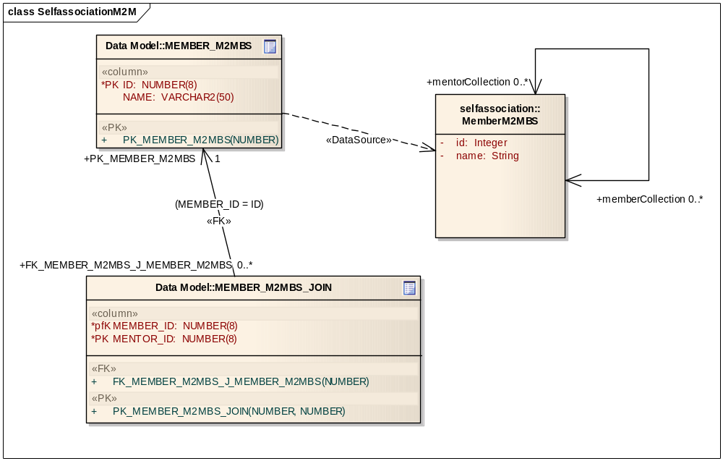
Many-to-Many Bi-directional Self Association
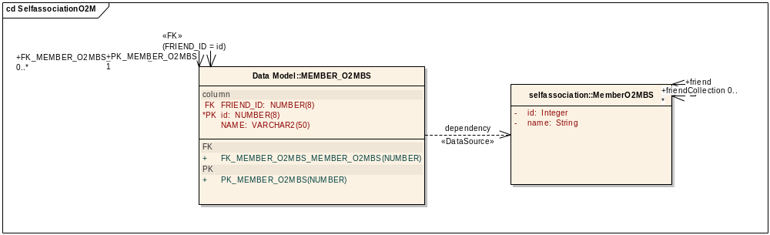
One-to-Many Bi-directional Self Association
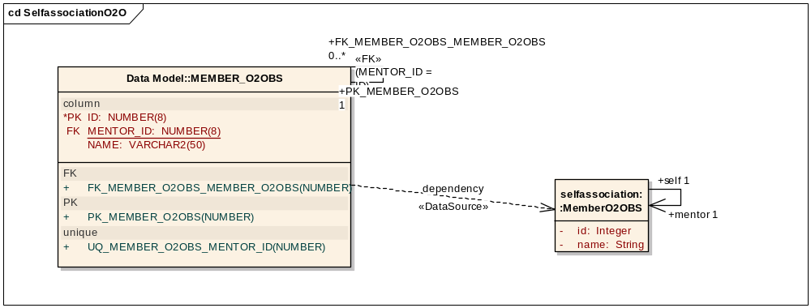
One-to-One Bi-directional Self Association

Testing
To test the enhancements made to provide support for Bi-Directional Self Associations, follow these steps:
- Modify the <project-generation directory>\build\codegen.properties file and ensure the new sdk.xmi file is being used to generate the SDK system.
- Run the SDK code generator process as usual using the “dist” or “build:SDK” targets.
- Verify that the following generated artifacts, located within the generation directory, \<project generation directory>\target\dist\exploded\output\example\codegen\, reflect both ends of the bi-directional self-association links:
  - Domain Java POJO’s: \gov\nih\nci\cacoresdk\domain\manytomany\bidirectional\selfassociation\MemberM2MBS.java, \gov\nih\nci\cacoresdk\domain\onetomany\bidirectional\selfassociation\MemberO2MBS.java, and /gov/nih/nci/cacoresdk/domain/onetoone/bidirectional/selfassociation/MemberO2OBS.java.
  - Hibernate Mapping files: /gov/nih/nci/cacoresdk/domain/manytomany/bidirectional/selfassociation/MemberM2MBS.hbm.xml, \gov\nih\nci\cacoresdk\domain\onetomany\bidirectional\selfassociation\MemberO2MBS.hbm.xml, and \gov\nih\nci\cacoresdk\domain\onetoone\bidirectional\selfassociation\MemberO2OBS.hbm.xml
  - XSD’s: gov.nih.nci.cacoresdk.domain.manytomany.bidirectional.selfassociation.xsd, gov.nih.nci.cacoresdk.domain.onetomany.bidirectional.selfassociation.xsd, gov.nih.nci.cacoresdk.domain.onetoone.bidirectional.selfassociation.xsd
  - xml-mapping.xml
  - unmarshaller-xml-mapping.xml
- Verify that the following generated Junit tests, located within the generation junit directory, /<project generation directory>/target/dist/exploded/output/example/codegen/junit/src, reflect both ends of the bi-directional self-association links for the testEntireObjectNestedSearch() test method ONLY (the HQL Critieria and CQL test methods do not contain association tests):
  - /test/gov/nih/nci/cacoresdk/domain/manytomany/bidirectional/selfassociation/MemberM2MBSTest.java
  - /test/gov/nih/nci/cacoresdk/domain/onetomany/bidirectional/selfassociation/MemberO2MBSTest.java
  - /test/gov/nih/nci/cacoresdk/domain/onetoone/bidirectional/selfassociation/MemberO2OBSTest.java
- Verify that the non-generated SDK junit tests, located under the \<project generation directory>\junit\src\ directory, execute without failures or errors:
  - \test\gov\nih\nci\cacoresdk\domain\manytomany\bidirectional\selfassociation\M2MBidirectionalSelfassociationTest.java
  - \example-project\junit\src\test\gov\nih\nci\cacoresdk\domain\onetomany\bidirectional\selfassociation\O2MBidirectionalSelfassociationTest.java
  - \example-project\junit\src\test\gov\nih\nci\cacoresdk\domain\onetoone\bidirectional\selfassociation\O2OBidirectionalSelfassociationTest.java

Automated JUnit Test Case Generation
https://gforge.nci.nih.gov/tracker/index.php?func=detail&aid=30729&group_id=148&atid=804
The caTissue Team has requested an option within the caCORE SDK to generate JUnit Test classes for each of the generated Logical Model domain classes.

A property, GENERATE_JUNITS, has been added to the codegen.properties file, which is used to toggle the generation of these tests. Generated JUnit classes and supporting jars and script to run the tests are placed within the \<project-generation>\target\dist\exploded\output\<project-name>\codegen\junit directory.

Testing
To test the enhancements made to provide support for automated JUnit test case generation, follow these steps:
- Modify the <project-generation directory>\build\codegen.properties, and enable automated junit test case generation by setting the GENERATE_JUNITS property to true; e.g., GENERATE_JUNITS=true.
- Run the code generator as usual using one of the “dist” or “build:SDK” targets.
- Verify that the <project-generation>\target\dist\exploded\output\<project-name>\codegen\junit\src directory contain *Test.java, *XMLDataTest.java, and *XSDTest.java Junit test classes for each of the classes within the Logical Domain model.
- Run the Junit tests by executing the readThickClientTest, xmlDataThickClientTest, and xsdTest targets, respectively, of the Ant build.xml file located within the \<project-generation directory>\target\dist\exploded\output\<project-name>\codegen\junit\ directory. Note: This last step assumes that the required database tables and data exist in the database referred to in the install.properties file successfully.

Note: The generated junit tests are generic. Some tests may fail simply because there is no data in the database for every single record.

Not-null attributes in generated Hibernate mapping files
https://gforge.nci.nih.gov/tracker/index.php?func=detail&aid=30753&group_id=148&atid=804
Hibernate mapping generated by SDK codegen does not have “not-null” attribute to a property element.
Ex:
<property name="birthdate"
type="date"
not-null="true"
update="false"/>

Some of our attributes and associations are null-able and by default SDK generates not-null="true" for all the attributes and associations. This is creating issues in caTissue application business logic at some places.

The new tag, “nci-not-null” is added to support “not-null” attribute on a property element. Adding this tag value to a column in a table would override default behavior of SDK code generation, which is, no “not-null” attribute at all on a property.

Parameterized Constructors
[#30524] SDK Code Generation - Parameterized Constructors – catissue
SDK generated code by default generates java classes without constructors. This would force a caller to use default constructor with no arguments. This feature request is to support adding constructors with parameters.

Ex: Specimen.java
//Default constructor
public void Specimen()
{
.
.
}

//Parameterized constructor
public void Specimen(Participent p)
{
.
.
}

Testing
- With default “sdk.xmi”, generate system with SDK and verify “sdk-toolkit\example-project\target\dist\exploded\output\example\codegen\src\gov\nih\nci\cacoresdk\domain\operations/ Specimen.java”. Make sure there are no constructors.
- Open “SDKTestModel.EAP” and update Specimen element in the logical model to have an operation called “Specimen” with parameter “value” of type “String”. Build SDK system and verify “sdk-toolkit\example-project\target\dist\exploded\output\example\codegen\src\gov\nih\nci\cacoresdk\domain\operations/ Specimen.java”. It should have constructor with following signature.

public void Specimen(String value)
{
}

Custom getter methods
[#30511] SDK Code Generation - Custom Getter Methods – catissue
SDK generates getter methods based on attribute names. This enhancement is to provide overloaded getter methods.

Testing
- With default “sdk.xmi”, generate system with SDK and verify “sdk-toolkit\example-project\target\dist\exploded\output\example\codegen\src\gov\nih\nci\cacoresdk\domain\operations/ Specimen.java”. Make sure there is a getter method called “getBarCode()” with following signature:
public String getBarCode(){
return barCode;
}

- Open “SDKTestModel.EAP” and update Specimen element in the logical model to have an operation called “getBarCode” with parameter “value” of type “String”. Set Return type as “String”.
- 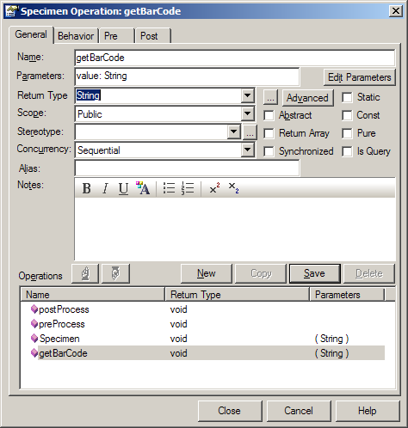
- Select operation properties and click on “Behavior” tab. Add following code to initial code section:

return (barCode == null) ? “test”:barCode;

- Build SDK system and verify “sdk-toolkit\example-project\target\dist\exploded\output\example\codegen\src\gov\nih\nci\cacoresdk\domain\operations/ Specimen.java”. It should have constructor with following signature.

public String getBarCode(String value){
return (barCode == null) ? “test”:barCode;
}
- Building the system should not generate any errors related to newly added operation.

Support for Comparable Interface
[#30508] SDK Code Generation - Support for Implementing Comparable interface – catissue
Comparable interface is a non-marker interface where implementing class has to implement compareTo(java.lang.Object) operation.

Testing
- Open “SDKTestModel.EAP” and add “Comparable” Interface to java.lang package. Please look at following screenshot.
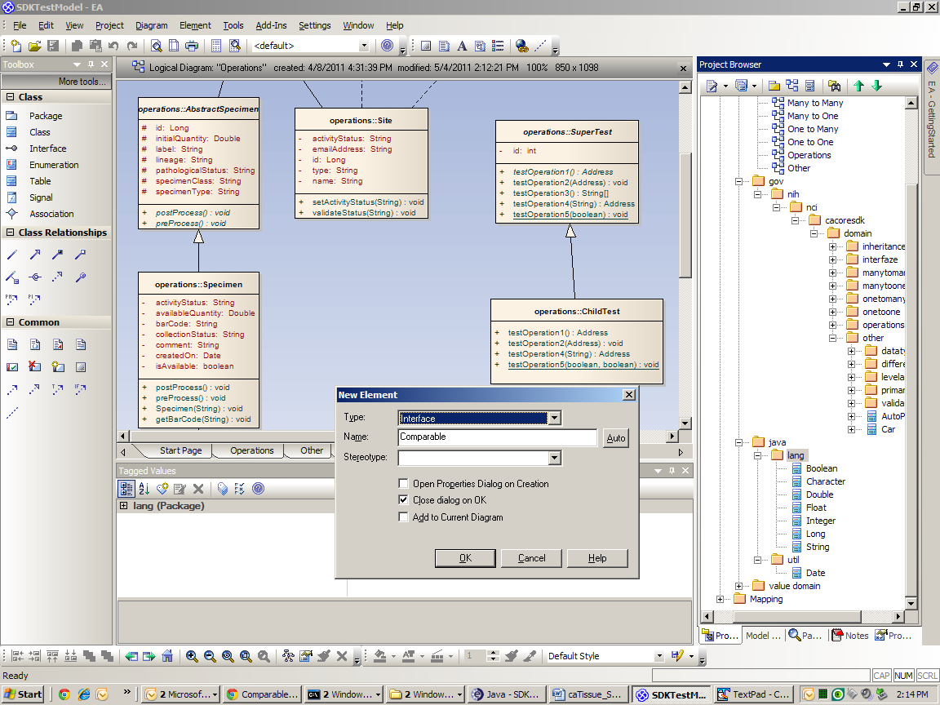

- Add “Comparable” interface to “Operation” diagram in logical model and create “Realization” dependency from Specimen to Comparable element. This association implies that Specimen is implementing Comparable interface. Please see following screenshot.
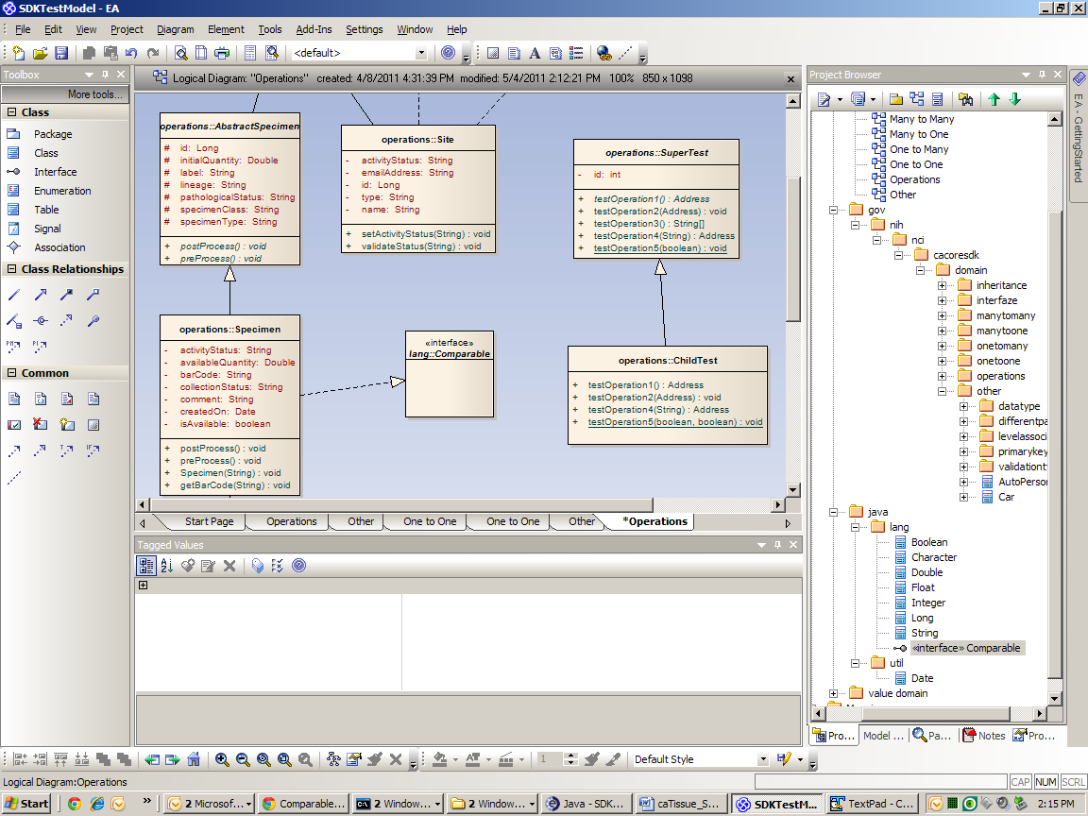
- Save the model to XMI and build SDK system. Following error should happen:
gov.nih.nci.cacoresdk.domain.operations.Specimen is not abstract and does not
override abstract method compareTo(java.lang.Object) in java.lang.Comparable
[javac] public class Specimen extends AbstractSpecimen implements Serializable, Comparable
[javac] ^
[javac] 1 error

- Go back to the model and add “compareTo” operation to Specimen. Add parameter as “object” of type “java.lang.Object”. See the following screenshot.
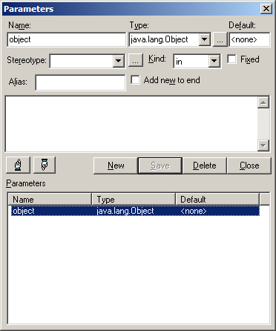
- Set return type to “int” and save the changes.
- Click on “Behavior” tag and add following code to intial code section:
return 0;
- Save the model to XMI and build the system. No errors should happen.
- Verify Specimen.java to make sure it is implementing Comparable interface and has compareTo implementation.

